Multi Criteria Evaluation of Parabolic Solar Cooker as a Domestic Cooking Device

THESIS
Submitted in partial fulfilment
of the requirements for the degree of
DOCTOR OF PHILOSOPHY

by
SANJAY D. POHEKAR

Under the Supervision of
Prof. M. Ramachandran

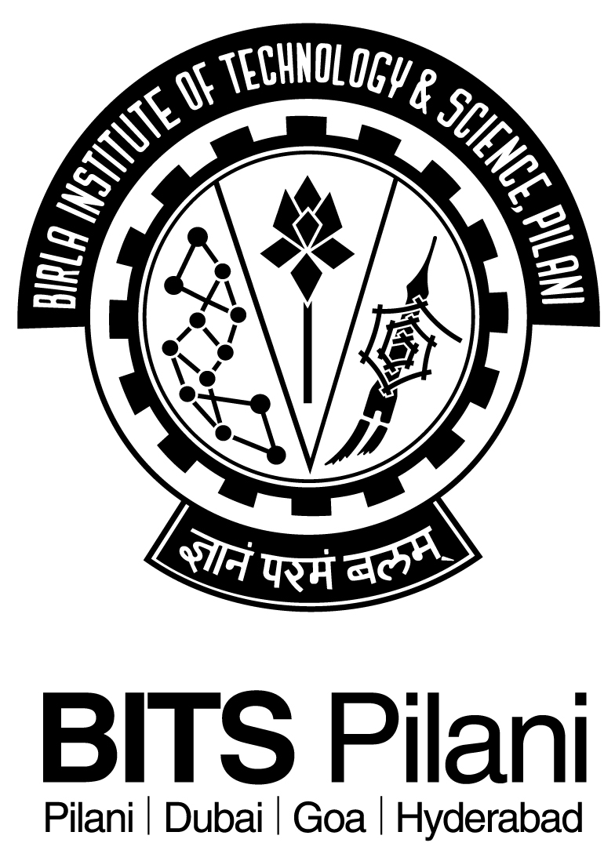

BIRLA INSTITUTE OF TECHNOLOGY AND SCIENCE, PILANI
2004

